1. **What software development methodology would you suggest for this situation and why?**

Based on the requirements and description of the situation, I would suggest using model **Agile** for this situation and here is the reason I chose this model:

1. Requirements characteristic

* Reliability:

+ The requirements of the project in this situation are well-defined, effective and highly practical.

+ The requirements of the project have been clearly stated and defined, but there may still be shortcomings and will be further exploited during the construction and development of the project.

+ The project may be put into use as soon as the first version is completed

* The project is likely to be high reliable.
* Types and number of requirement:

+ In this project, there are both non-functioncal and functioncal requirements

+ All the project’s requirements are clearly stated and do not cause conflict during the development process.

* Types and number of requirements defined quite complex and quite a few functions
* Frequently of the requirements can change:

+ This situation is mentioned: “The FMFS is a new development system, so there may be many changes during the development process”.

* In this project would be able to change requirements in the process of development.
* Determination of requirements at an early stage:

+ At the request of the project in the early stages is determined quite clear and completeness from the functionality to the system, but there can be easily to changes during the development process

* The project was initially clearly defined but still incomplete information

1. Development team

* Team size:

+ The development team may require 4-5 extensive experience and skills developers working closely with FU’team

* Level of understanding of user requirements by the developers:

+ The FMFS is a new development system so that this is the first time is capable of doing this project of the team.

+ Managers of other departments of FU commit to sending employees to join the project team to support project completion with high quality so that the development team can easily to understand of user requirement.

* High level of understanding.

1. User involvement

* Managers of other departments of FU commit to sending employees to join the project team to support project completion with high quality
* The project has participatory support from the client and will be able to respond to each phase of the project.
* Time constraints: “FU leadership expects the first version of the system to be put into use within 3 months”
* Quite short time.

**Conclusion:**

- From the reason I was above the model I would like to suggest is that **Agile** model.

- With high confidence and the number of requirements of the project's pretty big, projections always a new project and can easily change the requirements in development, with the team size is 4-5 very fit **Agile** model, extensive the level of understanding projections of the developers are pretty high, the project is supported many steps from FU’s university.

1. **What type and level/stage of testing would you suggest the team to do? Who will do test in each test level/stage?**

The type of testing that I suggest for the team to do this project is a combination of the type of testing functional testing and non-functional testing.

* Functioncal testing:

+ Unit testing (**test by Developer**):

<> Because this project is quite large, complex, and has a lot of functions so that we wanted to make sure that all individual components worked well.

<> Unit testing is a process that ensures that the individual components of a piece of software work and run as expected.

+ Intergration testing (test by Tester):

<> Because there are so many functions in this project and these will probably work interconnected, so we want all the interconnected functions to work well.

<> Integration testing is designed to determine whether individual software components function properly when they are connected together. Integration testing ensures that all connections between different units run smoothly.

* Non-functional testing:

+ Performance testing (**test by Developer and Tester**):

<> Because a university has a lot students and the number of students enrolling has increased very rapidly. So that, the system need to ensure performance when a lot members join the system in a time.

<> Performance testing is a type of testing that assesses how well a system performs under specific conditions, measuring aspects like speed, responsiveness, and stability. It helps ensure that the application meets performance expectations and can handle varying loads.

+ Security Testing (test by **Developer and Tester**):

<> Because we want all user information to be secure, leaking out can seriously affect individual users or an organization.

1. **List four functional requirements and two non-functional requirements that have been discussed on the iven descri tion of this project.**

* Functioncal requirements**:**

**+** The Student Service Staff can be put accommodation informations into the system, view student requests.

+ The Student can find available motels near FU campus and then register with model owners.

+ The Landlords can be allow motel owners to post motel information, update motel status and view student’s registration information.

+ The Student Service Manager can be allow manager to monitor and track the support actities to ensure every student’s request must be solved.

* Non-functional requirements:

+ The system needs to ensure high performance.

+ The system needs to ensure high security.

1. **Draw use casc diagram to describe at least 4 use-cases and two actors that havebeen discussed in your answers for the question.**

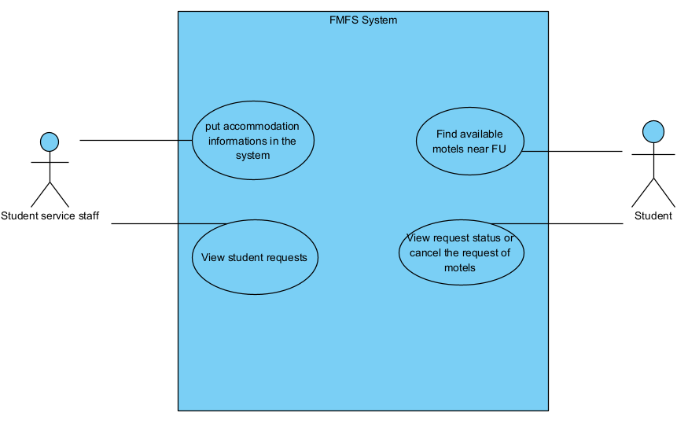

1. **Write 4 functional test cases for the use-cases listed in question 4 that you expect the testing team to use when testing those functions of the product.**

* **Test case 1: insert information into the system**

+ Description: Test case to test the functions import student list

+ Objective: Ensuring the function import work well.

+ Test steps:

= Login to the app.

= Click button import list.

= Choose a file to import.

= Save import

+ Expected result: Student service staff can insert informatio successfully

* **Test case 2: view student request**

+ Description: test case to test the functions view student request

+ Objective: Ensuring the function view request work well

+ Test steps:

= Login to the app/web.

= Click list all request.

= Choose request which you want to view

+ Expected result: Student service staff can view request.

* **Test case 3:**

+ Description:

+ Objective:

+ Test steps:

+ Expected result:

* **Test case 4:**

+ Description:

+ Objective:

+ Test steps:

+ Expected result:

1. **Write two user stories based on your answers in question 3**

* As a Student Service Staffs, I want to reply student’s request so that I can support students in finding boarding houses.
* As a Student, I want to find the available motels near FU campus so that I can move between my motels and school quickly.

